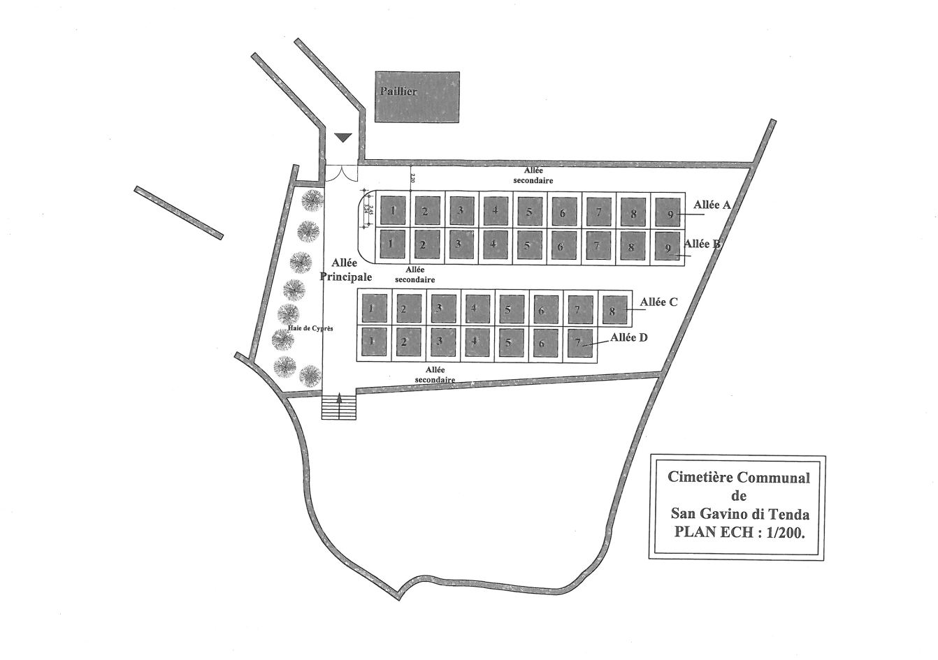
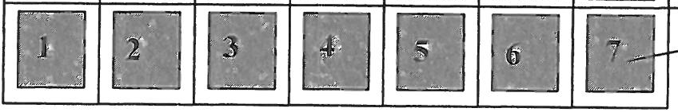
CIMETIERE – PLAN ET ATTRIBUTION DES CONCESSIONS
ALLEE A

A 1 = Famille CORTOPASSI
A 2 = CASTA Philippe
A 3 = SATTI Antoine
A 4 = SATTI Dominique
A 5 = DIEUTEGARDE Danielle
A 6 =
A 7 =
A 8 = PIETROTTI Laurent
A 9 = POGGIOLI François

ALLEE B

B 1 = Famille LUCIANI - CASTA
B 2 = Famille PIEVE-CASTA
B 3 = TOMI François
B 4 = SANTELLI André
B 5 = SANTELLI André
B 6 = ALESSANDRI Louis
B 7 = MORI Marcel/Mary Christine
B 8 = SAUMANDE
B 9 = MORI Joseph Marie
ALLEE C

C 1 = RISTORCELLI Roger
C 2 = RISTORCELLI Roger
C 3 = MORI joseph (Dédé)
C 4 = FILIPPINI Dédé
C 5 = POISMANS / MORI
C 6 = PICCININI Constance
C 7 = PIERESCHI Ange
C 8 = MORI Jean Joseph
ALLEE D

D 1 = MORI Antoine Marius
D 2 = PASQUINI Ange
D 3 = GROSSI Marie
D 4 = RASURI Dominique
D 5 = SIVIGLIANI Isabelle
D 6 =
D 7 = BASTELICA Jean-Noël

ALLEE E

D 1 =
D 2 =
D 3 =
D 4 =
D 5 =
D 6 =
D 7 =

ALLEE F

D 1 =
D 2 =
D 3 =
D 4 =
D 5 =
D 6 =
D 7 =

ALLEE G

D 1 =
D 2 =
D 3 =
D 4 =
D 5 =
D 6 =

Allée E
Allée F
Allée G

